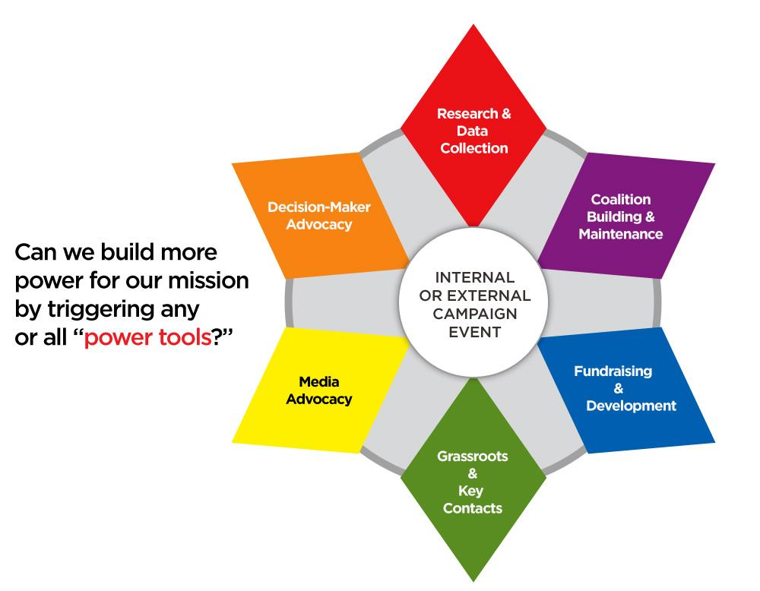
Power Prism Campaign Plan

GOAL(S)

What do you want?

Why do you want it?

Which institutions and individuals have the power to give you what you want?

When do you want it?

OBJECTIVES

In what SPECIFIC way will this be achieved (e.g., specific regulatory change, legislation, executive order).

SPECIFIC TARGETS TO INFLUENCE

MESSAGE

What is the most compelling way to communicate what you need?

RESEARCH AND DATA COLLECTION

INFORMATION NEEDED | TIMELINE | RESPONSIBLE PERSON

COALITION BUILDING AND MAINTENANCE
- What organizations have credibility with targets AND share the mission of your campaign?
- Consider the follow: Who wins if you win? Who shares you mission? Who shares your vision?

ACTIVITY | TIMELINE | RESPONSIBLE PERSON

FUNDRAISING AND DEVELOPMENT

ACTIVITY | TIMELINE | RESPONSIBLE PERSON

GRASSROOTS AND GRASSTOPS

ACTIVITY | TIMELINE | RESPONSIBLE PERSON

MEDIA ADVOCACY

ACTIVITY | TIMELINE | RESPONSIBLE PERSON

DECISION-MAKER ADVOCACY

ACTIVITY | TIMELINE | RESPONSIBLE PERSON

CAMPAIGN TIMELINE OVERVIEW

This is one example of a timeline; there are many formats you can use and you can include the level of detail you would like.

MONTH | ACTIVITIES | WHO IS RESPONSIBLE | WHAT IS NEEDED
January | Planning Meeting including coalition partners | Beth | Contact information for all coalition partners
 | Research previous activity on this issue | Don, Pascal | Interview informants and research proposed policies
 | Meet with potential partners | Kate | Contact list and priorities for potential new partners
February | Develop fact sheets for different audiences | Don, Pascal | Identify audiences, write factsheets, review and finalize
 | Continue to meet with potential partners | Kate | Contact list
 | Develop distribution plan for fact sheets | Kate | Identify places/ways to reach key audiences.
 | Plan membership retreat to introduce the campaign and campaign materials. | Beth, Pascal | Planning committee identified and begin to collect input from members, coalition partners, external allies, etc.

